**BASIC OPERATIONS IN SPSS**

**Assignment Number 1**

Register Number: 1740256

**Date:** 13/11/2017

--------------------------------------------------------------------------------------------

**Question 1**

**Aim** – Choose any SPSS file & write down any 3 different variables present in the file.

**Procedure -**

1. Open SPSS software and choose any data file.
2. Go to variable view and study the variables listed.

**Conclusion -**

The chosen data set is bankloan.sav and there are 12 variables.

**SCALE** – *age, employ, address, income, debtinc, creddebt, othdebt, preddef1, preddef2, preddef3*

**NOMINAL** – *default*

**ORDINAL** - *ed*

--------------------------------------------------------------------------------------------

**Question 2**

**Aim -** Open any SPSS file - choose any 1 data file. Find descriptive statistics for any 3 variables of interest.

**Procedure -**

1. Open SPSS software and choose any data file.
2. Click on Analyze on the top of the screen and a drop - down menu appears.
3. Choose Descriptive Statistics and then frequencies.
4. Choose any variable and click on the arrow button between the 2 boxes.
5. Then Click on Statistics and choose which operation is needed.
6. Click on any measure of descriptive statistics needed to perform operations.
7. Click on continue and then click on okay.
8. A new output screen appears with the desired operations.

**Calculations -**

|  |  |  |
| --- | --- | --- |
| **Statistics** | | |
| Age in years | | |
| N | Valid | 850 |
| Missing | 0 |
| Mean | | 35.03 |

|  |  |  |
| --- | --- | --- |
| **Statistics** | | |
| Level of education | | |
| N | Valid | 850 |
| Missing | 0 |
| Mean | | 1.71 |
| Median | | 1.00 |
| Mode | | 1 |
| Sum | | 1454 |

|  |  |  |
| --- | --- | --- |
| **Statistics** | | |
| Credit card debt in thousands | | |
| N | Valid | 850 |
| Missing | 0 |
| Skewness | | 3.702 |
| Std. Error of Skewness | | .084 |

|  |
| --- |
|  |

**Conclusion -**

The descriptive statistics for Age in years, level of education and credit card debt in thousands.

--------------------------------------------------------------------------------------------

**Question 3**

**Aim –** Use any data set to sort cases in SPSS.

**Procedure -**

1. Sorting data allows us to reorganize the data in ascending or descending order so that it helps in analysis.
2. There are 2 types of sorting in SPSS –
3. Sort cases i.e. row sort – will rearrange the rows either in ascending or descending order.

* Click on data & go to sort.
* It shows the different variables which can be sorted in that data.
* Choose any 1 variables & drag it to the next box.
* Choose ascending or descending and click ok.   
  **NOTE** – If we want to save the newly sorted data to a new file, then check the box of save file with sorted data. Click on OK and save the file.

1. Sort variables i.e. column sort

**Calculations -**

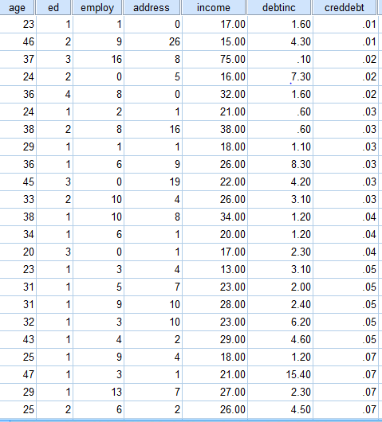

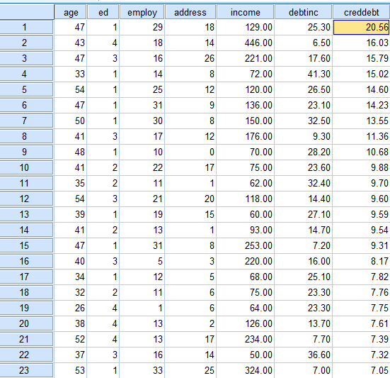

**Conclusion -**

The data set above for bankloan.sav is sorted cases in ascending and descending order.

--------------------------------------------------------------------------------------------